Fractions
Expression of Mixed as Improper Fraction and Improper as Mixed Fraction
It is possible to convert the improper fraction into a mixed fraction and vice versa.
Improper to Mixed Fraction
- Firstly, a division is carried out with denominator as the divisor and the numerator as the dividend.
- The quotient obtained through division becomes the whole part.
- The remainder obtained through division becomes the numerator of the fractional part.
- The divisor or the denominator of the improper fraction remains the denominator of the fractional part also.
- Therefore a mixed fraction is written as
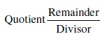

Mixed to Improper Fraction
Following is used to convert mixed to improper fraction:
- The whole is multiplied by the denominator and the numerator is added. The number r obtained is the numerator of the improper fraction.
- The denominator of the mixed fraction remains as the denominator of the improper fraction.
Problem: Express the following as mixed fractions. 20/3
Solution:
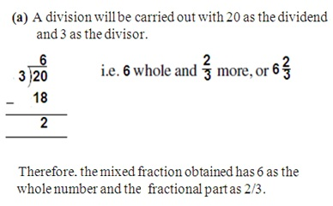
Problem: Express the following mixed fractions as improper fractions: 8 4/9
Solution:
In this case, 8 is the whole, 4 is the numerator and 9 is the denominator.
Thus putting these values in the following we get :
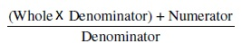
= (8*9) + 4
9
=31/9
Thus we get an improper fraction with 31 as the numerator and 9 as the denominator. It can also be seen that the value of this fraction is greater than 1.

